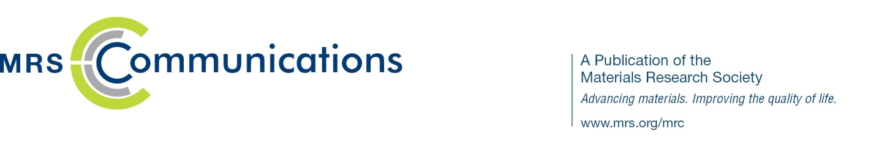
MRS Communications
A Letters Journal

Proposal to write a prospectiveS article

MRS Communications is a full-color, high-impact journal focused on groundbreaking work across the broad spectrum of materials research. Leveraging its access to the far-reaching technical expertise of MRS members and leading materials researchers from around the world, the journal boasts an experienced and highly respected board of principal editors, advisory board, and reviewers.
Prospectives articles are a unique feature of MRS Communications, offering succinct and forward-looking reviews of topics of interest to a broad materials research readership. Authoritative and balanced, they may deal with controversies or new and speculative areas of research for future consideration.
Technical Description:
- 7,000-10,000 words, 8-10 printed pages
- Multiple illustrations and figures encouraged
- Supplemental and multimedia data encouraged
- Max. 100 references
Generally, authors are invited by the editorial board to write Prospectives articles. However, interested authors may submit a proposal to write a Prospectives article for consideration by the editorial board. Please provide the following information if you are interested in writing a Prospectives article for MRS Communications. The editorial board will evaluate your proposal; if it is successful, you will be invited to submit the article.

Proposing author (or authors) and affiliations ____________________________________________________________________________________________________________________________________________________________________________________________________________________________________

Proposed topic area/title
____________________________________________________________________________________________________________________________________________________________________________________________________________________________________

Summary description of proposed Prospectives article (maximum of 500 words):
(This must include: rationale, objectives, why this topic is important, why the timing is critical, who the intended audience is.)
______________________________________________________________________________________________________________________________________________________________________________________________________________________________________________________________________________________________________________________________________________________

Brief description of author’s (or authors’) background qualifications that would be relevant to readers
____________________________________________________________________________________________________________________________________________________________________________________________________________________________________

Target completion date
__________________________________________________________________________________________________________________

Anticipated length (journal pages)
__________________________________________________________________________________________________________________

Contact author information (email/phone)
______________________________________________________________________________________________________________________________________________________________________________________________________________________________________________________________________________________________________________________________________________________

