The title should be in sentence case, 14pt and left-aligned

First Author’s Name¹, Second Author’s Name ^{1,2}, …. and Final Author’s Name ^{2,}

¹Affiliation 1; ²Affiliation 2 and ³Affiliation 3
[Notes: Authors’ first names and surnames must be given in full, with any middle initials as required.
Affiliations: Country must be included; US states must be 2-letter postal codes, not spelled out; no street addresses or zip codes]

Corresponding author: Author’s name, Email: xxxxx@xxxx

[insert a Page Break here, and remove this text]

Abstract
You must include continuous line numbering in your main document. First level headings should be in sentence case, left-aligned and bold: you can use Heading 1 in this template. Note that headings must NOT be numbered. Text should be fully justified, not left-aligned, and double-spaced throughout. The Abstract should be a short description of the work, with the main findings, and must not be longer than 250 words. Abbreviations should be kept to a minimum and must be explained at first mention. You should not begin a sentence with an abbreviation and they should not be used in headings. P values should not be included in the Abstract. The Abstract should not be written in italics.
In the following, please note that expected main headings for Research articles have been used. These are not generally applicable for Review papers and it is understood that section headings for Review papers are likely to be unique to the paper; however, you must still follow the formatting for Level 1, 2 and 3 headings please.

Keywords: List of key words; sentence case; separated by semicolons

[insert a Page Break here, and remove this text]

Key Findings
- You MUST add your Key Findings to the main document if the paper is still going through peer review. This should be a list of 3-5 bullet points describing the main findings of your work.
- If you are uploading final files after acceptance, then the Key Findings should be removed, as they are only used for peer review and are not published.
- All papers must include a Graphical Abstract, uploaded using the Graphical Abstract file type on ScholarOne, which will be available for published manuscripts with online browsing of the Cambridge Core website. The graphic could either be a photograph or illustrate image pertinent to your study and you must include a very short caption for it, one line at the very most, which must be placed underneath the image. Graphical abstract images must be supplied as 900px high or wide on its longest edge, and as PNG file type.

Introduction
This should be the next section, at least for Research articles, and may be several paragraphs long. Note that in each section or sub-section the first line should NOT be indented but the first line of subsequent paragraphs within that section or sub-section SHOULD (see next paragraph). No blank lines should be left between paragraphs within a section, but one blank line should be left between the end of one section/subsection and the heading of the next. Headings must not be numbered.
All references must be given using the Harvard style: see Instructions for Authors at https://www.cambridge.org/core/journals/parasitology/information/instructions-contributors#ref for detailed instructions. The last part of your Introduction must state the goal and objectives of your paper clearly and concisely.
Papers should be written in the third person, e.g. ‘it was found that’, not ‘we found’. You should avoid using ‘this/our paper/study/work’, etc. when referring to your work. You should also generally use the past tense.
Please keep abbreviations to a minimum and ensure they are explained at first mention (in the Abstract, if applicable, and again at first mention in the text). Wherever you list equipment that has been used, please state the make, model, and city and country of origin in brackets.

Materials and methods

Level 2 headings, or sub-headings, should be in italics, have an initial capital and be left-aligned
You can use Heading 2 in this template to format sub-headings. Headings should not contain abbreviations and must not be numbered.

Level 3 headings

Initial capital and Roman (upright) type for level 3 headings, left-aligned
You can use Heading 3 in this template for level 3 headings. Headings should not contain abbreviations and must not be numbered.

Results
In Research articles, the Results should be presented in a separate section from the Discussion. If you have a specific reason for writing a combined section, you should make a case for this in your covering letter for the Editor-in-Chief’s consideration. Results generally should not contain references.

Discussion
This should draw together your results, present possible reasons for your findings, comparisons with earlier results from other authors, possible reasons for different results, and suggestions for future work. In general, Tables and Figs should not be cited in the Discussion section.

Supplementary material. This heading should only be included if your paper contains supplementary material, i.e. material not necessary to replicate the findings of the article but which add depth or context to the main paper. Such files are usually made available on the Cambridge University Press platform alongside the article. If you have submitted such files, write the following under the heading (the typesetters will replace ‘DOI’ with the actual DOI: The supplementary material for this article can be found at [DOI].

Data availability. This section is only required if data is available elsewhere. Data Availability Statements are brief statements telling readers how they can access the data and other materials that would be necessary to replicate the findings of an article, in the interests of research transparency.

Acknowledgements. This section is optional. If you wish to credit, e.g. people who helped with the work but are not included in the list of authors, for instance statisticians or technicians, they should be listed in the acknowledgements.

Author’s contribution. This section is mandatory. A short statement should be provided indicating how each author contributed to the work. For example: AB and CD conceived and designed the study. CD and EF conducted data gathering. GH performed statistical analyses. AB, EF and GH wrote the article.

Financial support. This section is mandatory. If you received no funding or other financial support for the work, please write: This research received no specific grant from any funding agency, commercial or not-for-profit sectors.

Competing interests. This section is mandatory. You MUST declare any conflicts of interest in this section. If there are none, please write: The authors declare there are no conflicts of interest.

Ethical standards. This section is mandatory. You MUST include this section to declare Ethical Standards for studies involving vertebrates. For clarity, if your study did not include work with vertebrates, write ‘Not applicable’ here.

[Add a Page Break here, and remove this text]

References
The reference list should be formatted using a hanging indent (as this paragraph is) and no blank lines should be left between references. It must be arranged in alphabetical order by the surname of the first author.
In order to format the list with a hanging indent, the easiest way is to highlight the whole list, then drag the lower half of the tab indicator on the ruler slightly to the right:
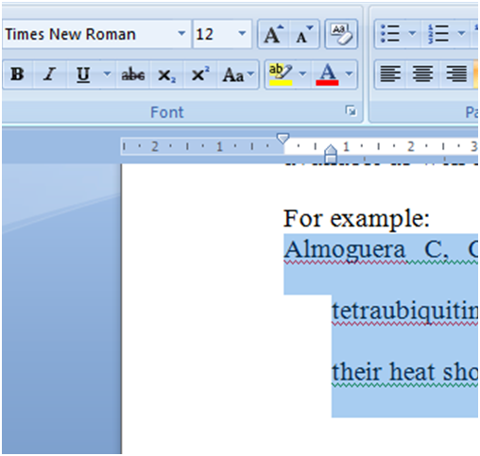
Ensure each reference is formatted as per the Instructions for Authors at https://www.cambridge.org/core/journals/parasitology/information/instructions-contributors.
You must make sure that every reference cited in the paper appears in the reference list, and vice versa.

[Add a Page Break here, and remove this text]
Appendix
This section is optional. Any Appendices should be placed after the References

[Add a Page Break here, and remove this text]
Tables and Figures must not be presented in the main text. Tables may be included in the main document file but if so must be placed after the reference list; alternatively they can be submitted as separate files. You must add page breaks between each Table.
All abbreviations and symbols must be explained in a footnote, including asterisks for P levels (* P < 0.05, ** P < 0.01, *** P < 0.001). Any other footnotes required should be inserted using superscript numbers, in numerical order.

[Add a Page Break here, and remove this text]
Figure x. The figure legends should be written at the end of the main document but all figures must be submitted as tif or eps files.

