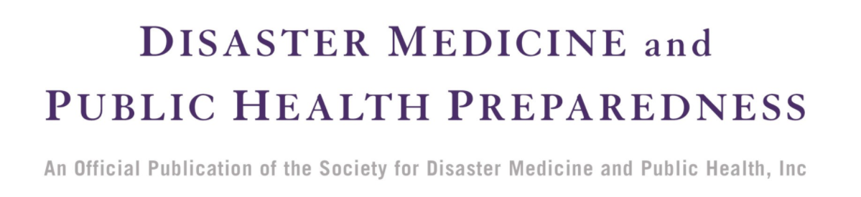
Manuscript Checklist for Submitting Authors

In an effort to streamline the production process and eliminate errors, we ask you to please consult the requirements below and ensure all points are addressed.

- All parts of the manuscript—abstract, text, acknowledgments, conflicts of interest, notes, reference list, list of figure captions (including source credits), tables, catalogues, appendices—are included, and pages are numbered consecutively.
- Keywords, author affiliations, and corresponding author email address are included and up to date.
- Any applicable funding sources and/or conflicts of interest have been disclosed. If no conflicts of interest exist, you are required to state “Conflicts of Interest: None” in your paper.
- Reference list and citations follow journal style. Refer to DMPHP’s instructions for authors here.
- All figures meet file type, size, and resolution guidelines. Refer to CUP’s author guide for submitting artwork for publication.
- You have secured permission to reproduce any images that are not their own, and included them in your manuscript with the required credit line.
- You have completed and submitted a copyright transfer form, an Authorship Responsibility form, and a Financial Disclosure form.

If you have submitted an article to be published on DMPHP’s Accepted Manuscript (AM) workflow, the following points are required:
- Please supply a clean, unmarked, version of the accepted manuscript with your final files —i.e., with no revisions shown by highlighted/strikethrough text.
- Please supply an un-blinded version of your manuscript with your final files.
- Please ensure that all figures/tables/supplementary materials mentioned in the text are included with your final files or in the manuscript directed.
If any of the above have not been completed, DMPHP will send your files back to the corresponding author for a resupply, delaying the publication of your manuscript.

If you have requested a PubMed Central/Europe PubMed Central deposit, the following points are required:
- Please supply a clean, unmarked, version of the accepted manuscript with your final files —i.e., with no revisions shown by highlighted/strikethrough text.
- Please supply an un-blinded version of your manuscript with your final files.
- Please ensure that all figures/tables/supplementary materials mentioned in the text are included with your final files or in the manuscript directed.
If any of the above have not been completed, PMC will send your files back to the Publisher for a resupply, delaying the posting of your manuscript.
For more information on all Disaster Medicine and Public Health Preparedness editorial policies, please visit the journal homepage on Cambridge Core.

