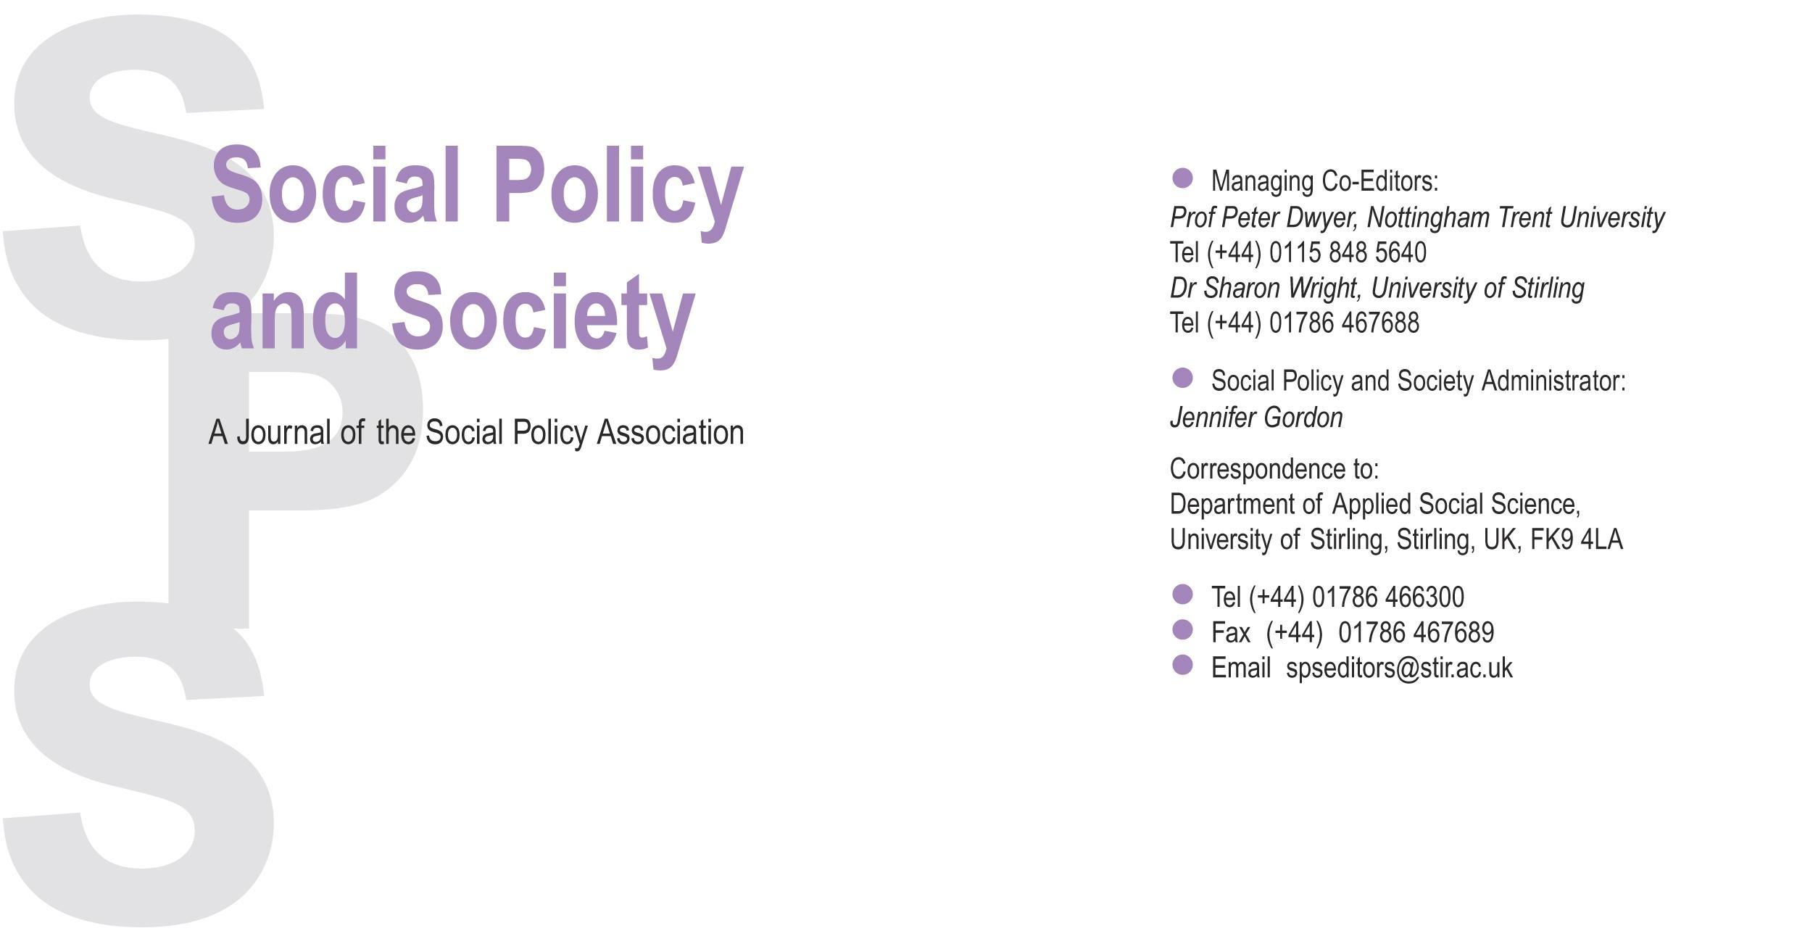

**Themed Section Proposal**

Please refer to the ‘[Instructions for prospective Guest Editors of a Themed Section](https://url.avanan.click/v2/___https://www.cambridge.org/core/journals/social-policy-and-society/information/instructions-contributors___.YXAxZTpjYW1icmlkZ2Vvcmc6YTpvOmZmZDU1YjdhZTc3M2EyMjkxMTI2ZmE4NWRkMjYxNTExOjY6YjQxOTo0N2E3Yzc2YzU2N2FhM2UwZjM4Zjg1M2MwN2VjMzcwYzJiNjk1ZjYyMmIwZDA0MzRkM2ViYjk3NzVjMmIxNDYyOnA6VDpG)’ before populating this document. When complete, please submit this proposal to *Social Policy and Society* via the journal’s submission site at [https://mc.manuscriptcentral.com/spa](https://url.avanan.click/v2/___https://mc.manuscriptcentral.com/spa___.YXAxZTpjYW1icmlkZ2Vvcmc6YTpvOmZmZDU1YjdhZTc3M2EyMjkxMTI2ZmE4NWRkMjYxNTExOjY6ZDk3NDoyOGRkYzY5ODhhOWE2NTIzOGY1ZmUzZGY1MmNiMTNlNmYzM2U5Y2QyZjI0Y2YzNzE2YzBkMzVmNWU3Mzg2NWQ5OnA6VDpG).

1. Themed Section title 2

2. Guest Editor(s) 2

3. Rationale 2

4. Contributors 3

5. List of contents 4

6. Abstracts 6

# Themed Section title

Click or tap here to enter text.

# Guest Editor(s)

Please provide the names, institutional affiliations and editorial experiences of all Guest Editors (up to 100 words for each guest editor).

Click or tap here to enter text.

# Rationale

This should outline the key issues to be explored in the section and the rationale for this (e.g. why are these issues topical, the extent to which the section would add to the existing body of knowledge on the topic, the section’s relevance to policy and practice and how they align with the aims and scope of the journal). Guest editors should also justify the authors chosen. The rationale should not exceed three pages in length.

Click or tap here to enter text.

# Contributors

Please provide the names and institutional affiliations of all proposed authors and up to three relevant publications of each author. Please only include authors who have agreed to contribute.

Click or tap here to enter text.

|  |  |
| --- | --- |
| List of contents All Themed Sections must include an Introduction, a State of the Art article, Useful Sources, four to six peer-reviewed articles. The total word count should not exceed 40,000 words. | |
| **1. Introduction**  (required) (this should include a section on relevance to policy and/or practice) | Title: Introduction  Author(s): Click or tap here to enter text.  Word count: Click or tap here to enter text. |
| **2. State of the Art article**  (required) | Title: Click or tap here to enter text.  Author(s): Click or tap here to enter text.  Word count: Click or tap here to enter text. |
| **3. Article**  (required) | Title: Click or tap here to enter text.  Author(s): Click or tap here to enter text.  Word count: Click or tap here to enter text. |
| **4. Article**  (required) | Title: Click or tap here to enter text.  Author(s): Click or tap here to enter text.  Word count: Click or tap here to enter text. |
| **5. Article**  (required) | Title: Click or tap here to enter text.  Author(s): Click or tap here to enter text.  Word count: Click or tap here to enter text. |
| **6. Article**  (optional) | Title: Click or tap here to enter text.  Author(s): Click or tap here to enter text.  Word count: Click or tap here to enter text. |
| **7. Article**  (optional) | Title: Click or tap here to enter text.  Author(s): Click or tap here to enter text.  Word count: Click or tap here to enter text. |
| **8. Article**  (optional) | Title: Click or tap here to enter text.  Author(s): Click or tap here to enter text.  Word count: Click or tap here to enter text. |
| **9. Useful Sources**  (this should include a selection of publications and other resources of relevance to academics, policy makers and practitioners) | Title: Useful Sources  Author(s): Click or tap here to enter text.  Word count: Click or tap here to enter text. |
| **Total Word Count**  Maximum 40,000 words (including tables, endnotes and bibliographies) | Click or tap here to enter text. |

# Abstracts

In this section, please provide the title, authors, and a 500-word abstract for each article. (Please delete any pages that are not needed.)

## 1. Introduction (including a section on relevance to policy and/or practice)

Title: Click or tap here to enter text.

Author(s): Click or tap here to enter text.

Abstract (400-600 words, excluding references):

Click or tap here to enter text.

## 2. State of the Art article (including the latest development of the debate on the topic)

Title: Click or tap here to enter text.

Author(s): Click or tap here to enter text.

Abstract (400-600 words, excluding references):

Click or tap here to enter text.

## 3. Article

Title: Click or tap here to enter text.

Author(s): Click or tap here to enter text.

Abstract (400-600 words, excluding references):

Click or tap here to enter text.

## 4. Article

Title: Click or tap here to enter text.

Author(s): Click or tap here to enter text.

Abstract (400-600 words, excluding references):

Click or tap here to enter text.

## 5. Article

Title: Click or tap here to enter text.

Author(s): Click or tap here to enter text.

Abstract (400-600 words, excluding references):

Click or tap here to enter text.

# Article

Title: Click or tap here to enter text.

Author(s): Click or tap here to enter text.

Abstract (400-600 words, excluding references):

Click or tap here to enter text.

## 7. Article

Title: Click or tap here to enter text.

Author(s): Click or tap here to enter text.

Abstract (400-600 words, excluding references):

Click or tap here to enter text.

# Article

Title: Click or tap here to enter text.

Author(s): Click or tap here to enter text.

Abstract (400-600 words, excluding references):

Click or tap here to enter text.