Robotica (year), page no doi:10.1017/xxxxx

RESEARCH ARTICLE

Robotica: Word Guidelines for authors
Cambridge First Author*1 and Cambridge Second Author2
1Electronic Products and Composition Group, Printing Division, Cambridge University Press, CB2 2BS.
2Department of Innovation Engineering, University of Salento - ISME node - Lecce, Italy.
*Corresponding author. E-mail: roberta.ingrosso@unisalento.it. Received: xx xxx xxx; Revised: xx xxx xxx; Accepted: xx xxx xxx Keywords: keyword1, keyword2

Abstract
This guide is for authors who are preparing papers for the Robotica journal using Microsoft Word. The Abstract should be one running paragraph of not more than 250 words.

Introduction
The first line of each section or sub-section should not be indented. However, the first line of subsequent paragraphs within the same section/subsection SHOULD be indented.
Main headings should be in bold, upright type and numbered 1, 2, 3, etc. (with the exception of the Abstract and the References). You can use Heading 1 in this template to format them correctly.

Second-order headings
Second-order headings, or sub-headings, should be in bold italics and numbered 1.1, 1.2, 2.1, 2.2, etc. as appropriate. A blank line should be left between sections / subsections. You can use Heading 2 in this template to format them correctly.

Third-order headings
Third order, or sub-sub-headings, should be in italics, not bold, and numbered 1.1.1, 1.2.1, 2.1.1, etc. as appropriate. You can use Heading 3 in this template to format them correctly.

Additional formatting guidelines

Titles, authors’ names and affiliation
The title of the article and the author’s name (or authors’ names) are used both at the beginning of the article for the main title and throughout the article as running headlines at the top of every page. The title is used on odd-numbered pages (rectos) and the author’s name appears on even- numbered pages (versos). Although the article title can run to several lines of text, the running headline must be a single line.

Lists
You may incorporate different types of list in your paper, if required:
- Bulleted lists.
- Numbered lists.
- Labelled lists.

Footnotes
The ROB journal style uses superior numbers for footnote references.

Tables
Tables can be presented at appropriate locations within the text. Normal journal style sets the table caption (centered) first. Vertical lines within tables are not used, and horizontal lines used only at the top, bottom, and under the column headings, as shown below.

Table 1. Results of Overloading for 3 Experimental Setups.

Program | Expt. | CPU | RelCPU | GC | Mem | RelMem
8 Queens | (a) | 2 88 | 1 00 | 6 | 1 7M | 1 00
Primes | (b)  (c)  (a) | 32 51  7 90  4 89 | 11 29  2 74  1 00 | 193  42  19 | 48 9M  11 3M  5 3M | 28 76  6 65  1 00
Nfib | (b)  (c)  (a) | 47 54  10 08  21 65 | 9 72  2 06  1 00 | 204  47  161 | 54 5M  13 0M  40 4M | 10 28  2 45  1 00
 | (b) | 221 65 | 10 24 | 1382 | 349 0M | 8 64
 | (c) | 21 30 | 0 98 | 161 | 42 0M | 1 03

Please do not use cross-referencing to label your tables. ScholarOne often cannot deal with this properly during conversion of the Word file to PDF for the reviewers and this results in mis-numbered tables. Therefore, please type the table numbers in manually.

Illustrations (or figures)
As with tables, figures may be presented at appropriate locations within the text. Figure captions should be below the figure itself, as shown below.

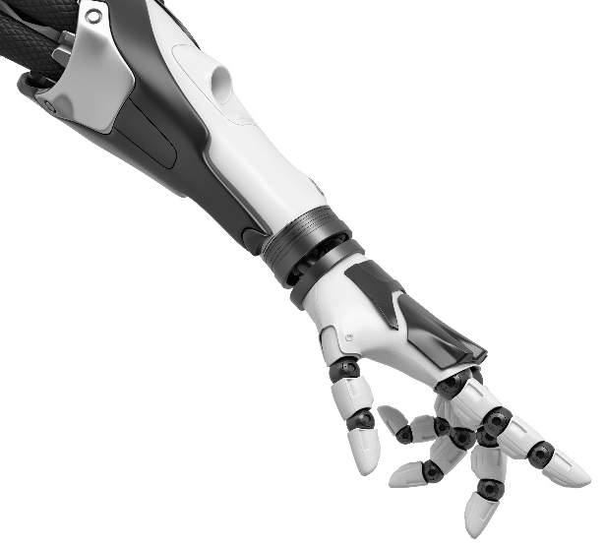
Figure 1. An example figure with title below.

Mathematics

Numbering of equations
Equations should be numbered (1a), (1b) etc. For example:
(1a)

and

(1b)

Required Declarations
There are several declarations that must appear in every paper before the reference list, as follows:
Author Contributions. A short statement must be provided indicating how each author contributed to the work. For example: AB and CD conceived and designed the study. CD and EF conducted data gathering. GH performed statistical analyses. AB, EF and GH wrote the article.

Financial Support. If you have nothing to declare, write This research received no specific grant from any funding agency, commercial or not-for-profit sectors.

Conflicts of Interest. You must declare any potential conflicts of interest, whether personal, financial or other. If there is nothing, write The authors declare no conflicts of interest exist.

Ethical Approval. If your paper includes experimentation with vertebrates, you must give details here of the body that approved the study, together with any relevant identification number. If your study did not include such experiments, write Not applicable.
You may also include an Acknowledgements section if you wish. Please note that this must be separate from the Financial Support declaration.

References
Robotica uses a Vancouver style of referencing. Further details are given below.

References in the text
References in the text are given by a reference number in square brackets, i.e. [4]

List of references
The following listing shows some references prepared in the style of the journal. Note that the heading for this section is not numbered.

References
- G. Antonelli, Underwater Robots, vol. 96. Springer Tracts in Advanced Robotics (Springer International Publishing, Switzerland, 2014).
- T. I. Fossen, Handbook of Marine Craft Hydrodynamics and Motion Control (John Wiley & Sons, Ltd., United Kingdom, 2011).
- P. Cardenas and E. A. de Barros, “Estimation of AUV hydrodynamic coefficients using analytical and system identification approaches,” IEEE J. Ocean. Eng., 1–20 (2019). 10.1109/JOE.2019.2930421
- M. Caccia, G. Indiveri and G. Veruggio, “Modelling and identification of open-frame variable configuration unmanned underwater vehicles,” IEEE J. Ocean. Eng. 5, 227–240 (2000).
- Z. Peng, J. Wang and Q.-L. Han, “Path-following control of autonomous underwater vehicles subject to velocity and input constraints via neurodynamic optimization,” IEEE Trans. Ind. Electron. 66(11), 8724–8732 (2018).

This shows how a footnote is typeset.

