Example of incorrect table formatting:
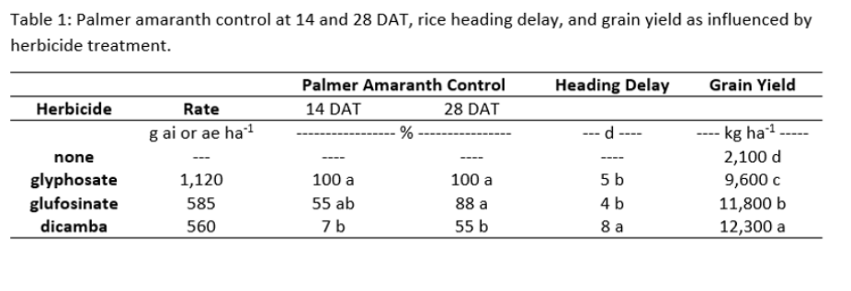
Example of correct table formatting:
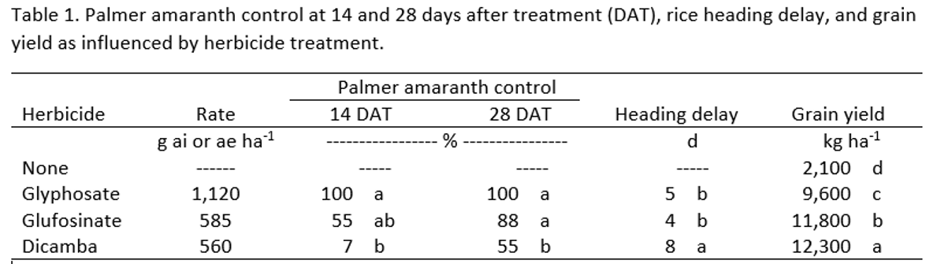

Some common errors in tables:
- Redefine all abbreviations used in each table, even if the definition has already been given the text.
- All text within each table should be in lowercase letters except for the first word of a phrase or sentence and proper nouns that should have initial capitals.
- The unit of measurement for a column of figures should be abbreviated and placed at the top of the column. Do not place the unit of measurement in parentheses.
- Letters associated with a value should be placed in a separate column from the number (both under the same column heading). This facilitates proper alignment.
- Values in the first column should be flush left.
- Column headings should not be bold.

